ABSTRACT

The rapid advancement of artificial intelligence and natural language processing (NLP) has opened the door to new modes of human-computer interaction. Among these, chatbots have emerged as a powerful and popular application. This project presents a basic text-based chatbot built using Python, aimed at simulating simple human-like conversations. It utilizes fundamental programming logic and optionally leverages NLP libraries like NLTK or spaCy to process and understand user input more effectively.The primary goal of the chatbot is to interact with users through text, respond appropriately to common questions or greetings, and maintain a natural conversational flow. Identify key phrases or patterns within user text, enabling the chatbot to generate meaningful responses.

To enhance the bot’s linguistic understanding, NLP techniques such as tokenization, lemmatization, and reflection are incorporated. The NLTK library, widely used for educational and research purposes, provides essential tools for breaking down and interpreting user input . This chatbot can be further expanded to support context awareness, machine learning-based classification, and integration with APIs or messaging platforms. For now, it serves as an educational tool and a prototype for more sophisticated AI-driven conversational agents.

**Introduction**

In today's digital world, conversational agents or chatbots are increasingly being used to automate communication with users. This project involves the development of a text-based chatbot using Python and Natural Language Processing (NLP) techniques via the NLTK library. The chatbot is capable of interacting with users through a terminal or console interface, offering simple responses to queries.

With the rise of artificial intelligence and machine learning, the way humans interact with machines has drastically evolved. One of the most prominent innovations in this domain is the development of chatbots—computer programs designed to simulate conversation with human users. These virtual agents are now widely used in customer service, healthcare, education, and entertainment to provide instant assistance and reduce human workload.

A chatbot is essentially an interface that allows users to communicate with a system through natural language, either in text or voice format. In this project, we focus on building a text-based chatbot using Python and Natural Language Processing (NLP) techniques provided by the Natural Language Toolkit (NLTK) library. The chatbot is capable of recognizing simple intents, processing natural language queries, and generating appropriate responses .

.

**1.1SYSTEM REQUIREMENTS**

**Hardware Requirements:**

* + - * Processor: Intel i3 or higher
      * RAM: 4 GB or more
      * Storage: 100 MB free space

**Software Requirements:**

* + - * Python 3.6 or higher
      * NLTK library
      * NumPy
      * Scikit-learn
      * Operating System: Windows/Linux/macOS

**2. SYSTEM STUDY**

**2.1 Existing System**

In traditional systems, user queries are handled manually or through static FAQs. These systems are not scalable and lack real-time interaction. Rule-based chatbots exist but often lack the ability to understand the user's intent.

* 1. **Drawbacks of Existing System**
     + Static response generation.
     + No contextual understanding.
     + Poor scalability.
     + Lack of learning from conversations.

**2.3 Proposed System**

The proposed system is an interactive text-based chatbot that utilizes Natural Language Processing (NLP) techniques such as tokenization, lemmatization, and TF-IDF vectorization to understand user input and generate relevant responses based on a predefined corpus. The proposed system is a text-based intelligent chatbot that utilizes Natural Language Processing (NLP) to provide meaningful and context-aware responses to user input. This chatbot is built using Python and the Natural Language Toolkit (NLTK), and it represents an improvement over traditional rule-based or menu-driven chatbot systems.

**Objectives**

* Develop an interactive chatbot that communicates with users using natural language.
* Use NLP techniques such as tokenization, lemmatization, vectorization, and semantic similarity to interpret user queries.
* Provide accurate and relevant responses by comparing user input to a predefined knowledge base (corpus).
* Offer a flexible and extensible architecture that can be enhanced with advanced AI and ML features in the future.

**2.4 Features**

* **Text-Based Interaction**

The chatbot interacts with users via a simple text interface in the terminal or command line.

* **Natural Language Processing (NLP)**

Uses NLTK for processing user inputs through tokenization, lemmatization, and normalization.

* **Greeting Recognition**

Recognizes and responds to common greetings like “hi”, “hello”, “hey”, etc., with predefined responses.

* **TF-IDF Vectorization**

Converts text data into numerical format using Term Frequency-Inverse Document Frequency to evaluate the importance of words.

* **Semantic Response Matching**

Uses cosine similarity to match user input with the most relevant sentence from a predefined corpus.

* **Fallback Response**

If the chatbot does not understand a query, it provides a polite fallback response (e.g., "I’m sorry! I don’t understand you.").

* **Exit Command**

Allows users to exit the conversation gracefully by typing “bye”.

* **Lightweight and Fast**

Requires minimal resources, making it suitable for low-end systems or deployment in constrained environments.

**3. System Design and Development**

**3.1 File Design**

* + chatbot.py: Main application file.
  + corpus.txt: Contains chatbot knowledge base.
  + requirements.txt: Lists Python dependencies.

**3.2 Input Design**

User inputs are taken via the command line in natural language. These inputs are cleaned, tokenized, and lemmatized before being processed.

**3.3 Output Design**

The chatbot prints appropriate responses on the console. Responses are selected based on similarity to known sentences in the corpus.

**3.4 Code Design**

**Chatbot.py**

import nltk

import numpy as np

import random

import string

from sklearn.feature_extraction.text import TfidfVectorizer

from sklearn.metrics.pairwise import cosine_similarity

# Download required NLTK data

nltk.download('punkt')

nltk.download('wordnet')

# Load corpus

with open("corpus.txt", "r", errors='ignore') as file:

raw_text = file.read().lower()

# Sentence and word tokenization

sent_tokens = nltk.sent_tokenize(raw_text)

word_tokens = nltk.word_tokenize(raw_text)

# Lemmatizer

lemmer = nltk.stem.WordNetLemmatizer()

def LemTokens(tokens):

return [lemmer.lemmatize(token) for token in tokens]

remove_punct_dict = dict((ord(punct), None) for punct in string.punctuation)

def LemNormalize(text):

return LemTokens(nltk.word_tokenize(text.lower().translate(remove_punct_dict)))

# Greeting inputs and responses

GREETING_INPUTS = ("hello", "hi", "greetings", "hey", "what's up")

GREETING_RESPONSES = ["hello", "hi there", "greetings!", "hey!", "hi :)"]

def greeting(sentence):

for word in sentence.split():

if word.lower() in GREETING_INPUTS:

return random.choice(GREETING_RESPONSES)

# Generate chatbot response

def response(user_input):

user_input = user_input.lower()

sent_tokens.append(user_input)

tfidf_vec = TfidfVectorizer(tokenizer=LemNormalize, stop_words='english')

tfidf = tfidf_vec.fit_transform(sent_tokens)

similarity_scores = cosine_similarity(tfidf[-1], tfidf[:-1])

index = similarity_scores.argsort()[0][-1]

flat = similarity_scores.flatten()

flat.sort()

score = flat[-2]

if score == 0:

reply = "I'm sorry! I don't understand you."

else:

reply = sent_tokens[index]

sent_tokens.remove(user_input)

return reply

# Main chatbot function

def chatbot():

print("Chatbot: Hi! I'm your assistant. Type 'bye' to exit.")

while True:

user_input = input("You: ")

if user_input.lower() == 'bye':

print("Chatbot: Goodbye! Take care.")

break

elif user_input.lower() in ['thanks', 'thank you']:

print("Chatbot: You're welcome!")

break

else:

if greeting(user_input) is not None:

print("Chatbot:", greeting(user_input))

else:

print("Chatbot:", response(user_input))

# Run the chatbot

if __name__ == "__main__":

chatbot()

**3.5 Database Design**

**1.Current Implementation: Corpus as a Text Database**

In the current system, the chatbot’s “database” is a plain text file (corpus.txt). This acts as a static knowledge base containing sentences that the chatbot can refer to when generating responses.

* Each line in corpus.txt represents a possible response.
* Sentences are separated by newline characters.

**2.Proposed Extended Design: Using a Structured Database**

* To enhance scalability and flexibility, the chatbot can be integrated with a relational database like SQLite or MySQL. This allows for more dynamic data handling, user-specific data, and administrative capabilities.
* Purpose: Store conversations for analysis, debugging, or improvement.

**3.6 System Development**

Tools Used:

* Python 3
* NLTK: for text preprocessing
* NumPy: for numerical operations
* Scikit-learn: for vectorization and similarity computation

Development Process:

* Load and preprocess data.
* Design greeting and conversation logic.
* Implement chatbot loop.
* Integrate TF-IDF for response generation.
* Test and improve accuracy.

**4. Testing and Implementation**

**Testing**

* **Unit Testing**:

Each function was tested independently (e.g., tokenization, response generation).

* **Integration Testing**:

Tested the system as a whole to ensure proper interaction between modules.

* **User Testing**:

Tested with different sample queries to validate responses.

**Implementation Steps**

* Install dependencies via pip install -r requirements.txt.
* Run the program using python chatbot.py.
* Interact with the chatbot in the terminal window.

**5. CONCLUSION**

The development of this basic text-based chatbot using Python demonstrates how natural language processing and simple programming logic can be combined to simulate human-like conversations. By utilizing libraries such as NLTK or spaCy, the chatbot is able to process user input more effectively and deliver relevant responses, enhancing the overall interaction experience.Though simple in design, the chatbot serves as an excellent starting point for understanding the fundamentals of conversational AI. It introduces essential concepts such as text preprocessing, pattern matching, and response generation. The use of rule-based logic ensures ease of implementation while laying the groundwork for future improvements.

**6.BIBLIOGRAPHY**

* + - NLTK Documentation – https://www.nltk.org/
    - Python Official Documentation – https://docs.python.org/3/
    - Natural Language Processing with Python (Book by Steven Bird, Ewan Klein, and Edward Loper)
    - Regular Expressions in Python –shttps://docs.python.org/3library/re.html

**APPENDICES**

**Data Flow Diagram (Level 0 – Context Level)**

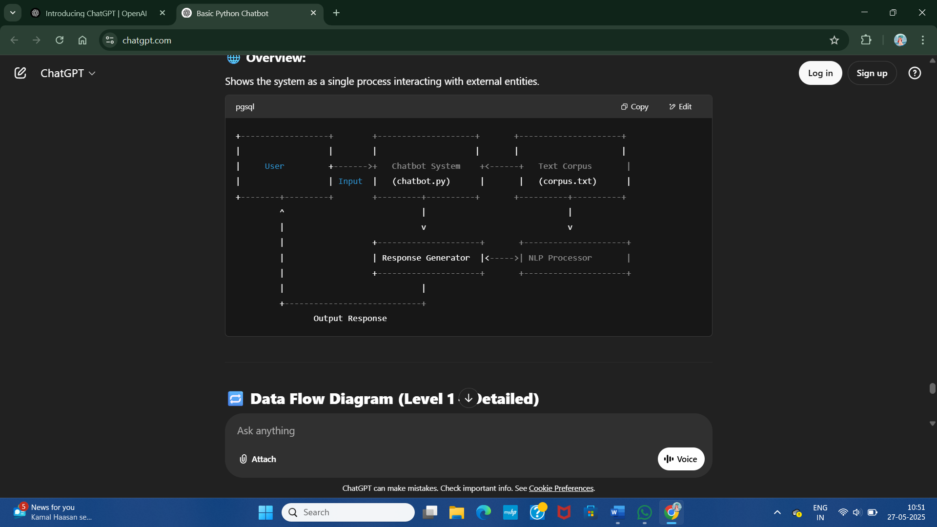

**Data Flow Diagram (Level 1 – Detailed)**

+------------------+

| User |

+--------+---------+

|

| 1. Enters message

v

+--------+---------+ +--------------------------+

| NLP Processor |<----------------------+ Corpus (corpus.txt) |

| - Cleans input | | - Static knowledge base |

| - Tokenizes | | - Contains Q&A sentences |

| - Lemmatizes | +------------+-------------+

+--------+---------+ |

| 2. Preprocessed Text |

v |

+--------+---------+ |

| TF-IDF Vectorizer| |

| + Cosine Similarity |

| - Converts input & corpus to vectors |

| - Finds best match |

+--------+---------+ |

| 3. Best Match Sentence |

v |

+--------+---------+ |

| Response Generator|-----------------------------------+

| - Returns matched sentence or default response

+--------+---------+

|

| 4. Sends response

v

+--------+---------+

| User |

**SAMPLE INPUT**

import nltk

import random

import re

# nltk.download('punkt') # Uncomment if not already downloaded

reflections = {

"i am": "you are",

"i'm": "you are",

"my": "your",

"you": "me",

"me": "you"

}

responses = {

"hello": ["Hi there!", "Hello!", "Hey!"],

"how are you": ["I'm fine, thank you!", "Doing well, how about you?"],

"what is your name": ["I'm a chatbot!", "You can call me Chatty!"],

"default": ["Sorry, I didn't get that.", "Can you rephrase that?"]

}

def reflect(sentence):

words = sentence.lower().split()

reflected = [reflections.get(word, word) for word in words]

return " ".join(reflected)

def respond(user_input):

user_input = user_input.lower()

for pattern in responses:

if re.search(pattern, user_input):

return random.choice(responses[pattern])

return random.choice(responses["default"])

def chatbot():

print("Chatbot: Hello! Type 'bye' to exit.")

while True:

user_input = input("You: ")

if user_input.lower() == "bye":

print("Chatbot: Goodbye!")

break

response = respond(user_input)

print("Chatbot:", response)

if _name_ == "_main_":

    chatbot()

**SAMPLE OUTPUT**

|  |
| --- |
| Chatbot: Hi! I'm your assistant. Type 'bye' to exit.  You: hello  Chatbot: hi  You: what can you do  Chatbot: I can have simple conversations with you and answer basic questions.  You: bye  Chatbot: Goodbye! Take care. |